QUESTION BANK
- Answer the questions on the basis of Figure:
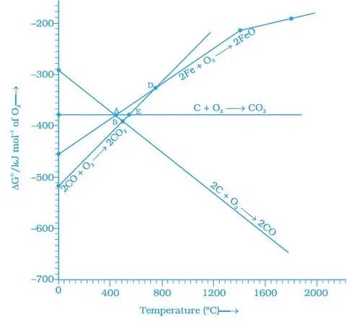
- Choose the correct option of temperature at which carbon reduces FeO to iron and produces CO.
(i) Below temperature at point A.
(ii) Approximately at the temperature corresponding to point A.
(iii) Above temperature at point A but below temperature at point D.
(iv) Above temperature at point A.
- Below point ‘A’ FeO can ______________.
(i) Be reduced by carbon monoxide only.
(ii) Be reduced by both carbon monoxide and carbon.
(iii) Be reduced by carbon only.
(iv) Not be reduced by both carbon and carbon monoxide.
- For the reduction of FeO at the temperature corresponding to point D, which of the following statements is correct?
(i) ΔG value for the overall reduction reaction with carbon monoxide is zero.
(ii) ΔG value for the overall reduction reaction with a mixture of 1 mol carbon and 1 mol oxygen is positive.
(iii) ΔG value for the overall reduction reaction with a mixture of 2 mol carbon and 1 mol oxygen will be positive.

(iv) ΔG value for the overall reduction reaction with carbon monoxide is negative.
2. Describe the principal controlling each of the following processes:
a) Vapour phase refining of titanium metal.
b) Froth floatation method of concentration of a sulphide ore.
3. Name the principal ore of aluminium. Explain the significance of leaching in the extraction of aluminium.
4. At temperatures above 1073K coke can be used to reduce FeO to Fe. How can you justify this reduction with Ellingham diagram?
5. Why is an external emf of more than 2.2V required for the extraction of Cl₂from brine?
6. Although carbon and hydrogen are better reducing agents but they are not used to reduce metallic oxides at high temperatures. Why?
7. The mixture of compounds A and B is passed through a column of Al₂O₃ by using alcohol as eluant. Compound A is eluted in preference to compound B. Which of the compounds A or B, is more readily adsorbed on the column?
8. What is the role of depressant in the concentration of sulphide ore?
9. Name the concentrating techniques of :
a. Heavy ore
b. magnetic ore
c. leaching in noble metals and aluminium oxide
10. Distinguish between roasting and calcinations.
11. Explain the concept thermodynamics in pyrometallurgy.
12. Explain the principle behind:
a. zone refining
b. Chromatography
13. How will extract the following metals from its ore:
a. Cu
b. Al
c. Zn
14. Explain the different temperature zones in the blast furnace involved in the extraction of Fe.
15. Which method is used for refining Zr and Ti? Explain with equation.

